

MUMBAI EDUCATIONAL TRUST
MET INSTITUTE OF COMPUTER SCIENCE

Program Number | 04
Roll Number | 1550
Title of program | HDFS Commands
Objective | HDFS Commands

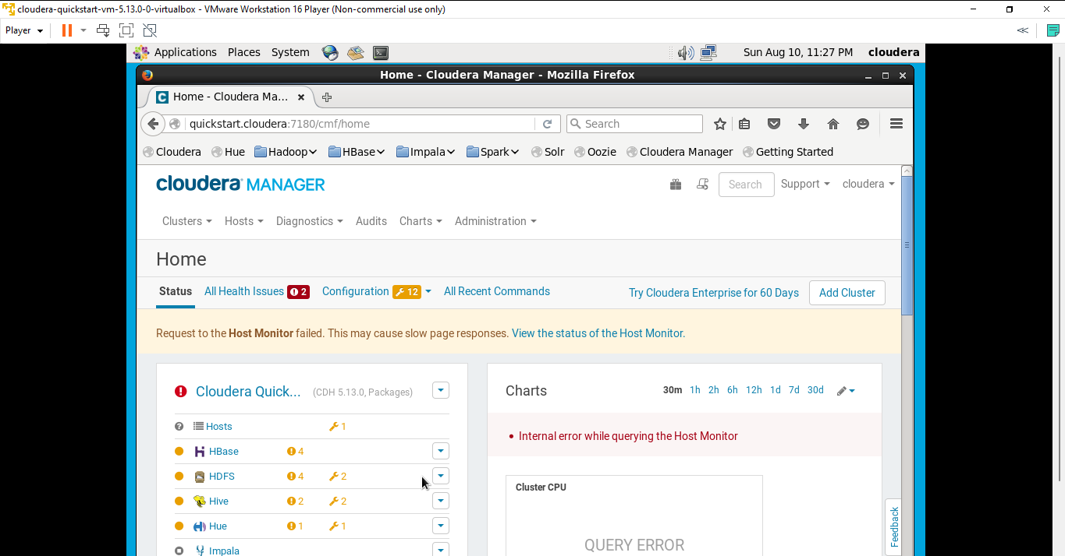

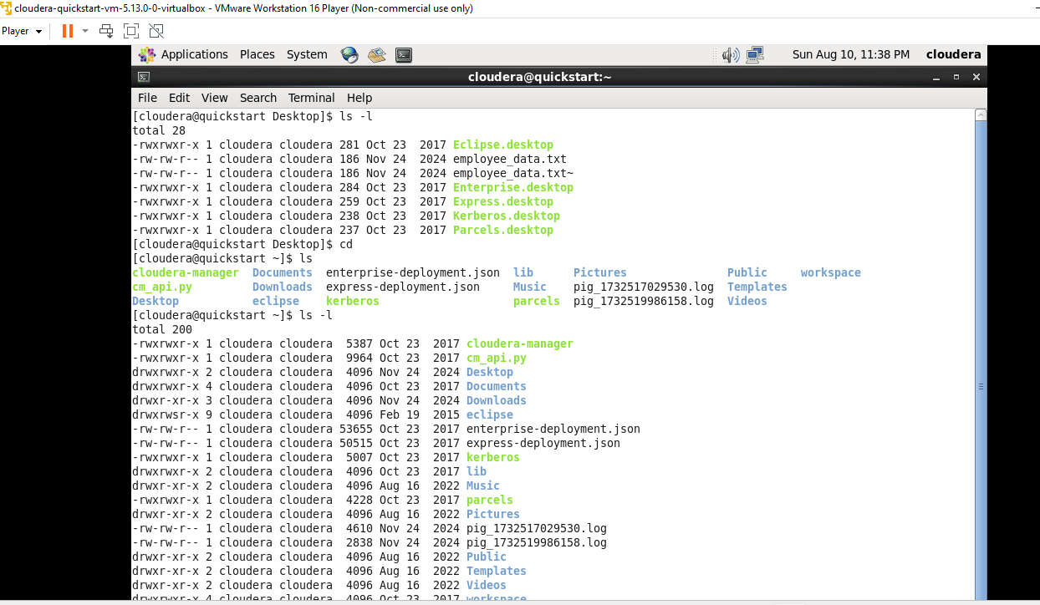


Insert for insertion

Esc for stop writing
:wq for exit


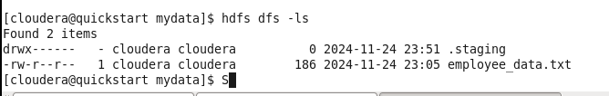
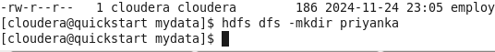
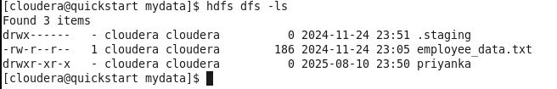
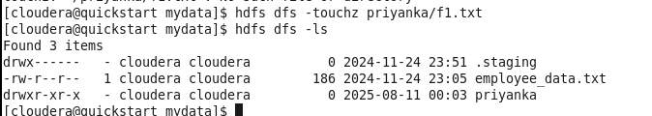
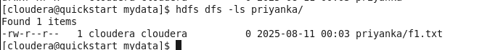
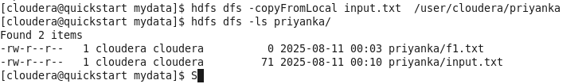
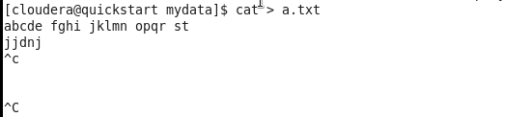

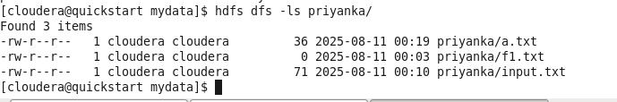
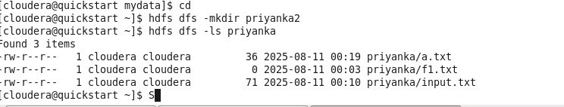
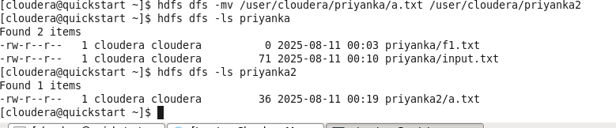

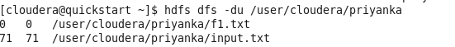
du give individual filesize
